
Kingsway Christian College
Maths Department

Course: Mathematics Methods Year 12
Assessment Task: Test 4 – Logarithms
Student Name: ________________________________________________________
Date: 26th June 2017
Assessment Score: ____________ / 43
Year Score: __________________
Comments: ________________________________________________________
___________________________________________________________________________
___________________________________________________________________________
___________________________________________________________________________
___________________________________________________________________________
___________________________________________________________________________
___________________________________________________________________________
___________________________________________________________________________
___________________________________________________________________________

Teacher signature: ________________________________________________________

Parent/ Guardian signature: _____________________________________________
Comments: ________________________________________________________
___________________________________________________________________________

METHODS YEAR 12 Test 4 2017
Logarithms
Resource Free Time: 35 mins Marks: / 40
No notes or calculators allowed for this section.

Question 1 (5 marks)
Evaluate the following, giving your answer as a single log term:
$\frac{(log{5-\log{3)²}}}{\log{\frac{3}{5}}}$

Question 2 (9 marks)
Solve each of the following equations. Leave answers in logarithmic form where necessary.
(a) (4 marks)

- $3^{2x+1 }-5\left(3^{x}\right)-2=0$ (5 marks)

Question 3 (5 marks)
If $\log_{10}{2=x }$and $\log_{10}{3=y. }$ Express the following in terms of $x$ and $y$
- $\log_{10}{0.6}$ (2 marks)

- $\log_{10}{45 }$ (3 marks)

Question 4 (3 marks)
The function $f(x)=\log{(bx-2)}$ is drawn below.

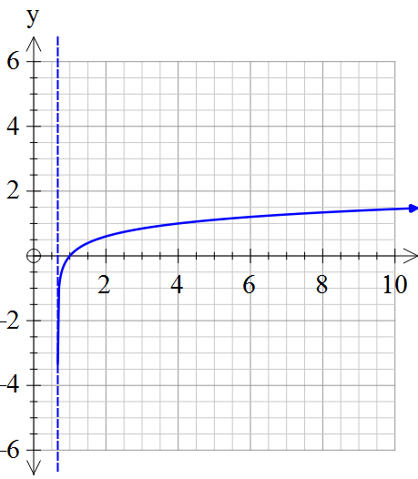

(a) Determine the value of b. (2 marks)

(b) Use the graph to approximate the solution to $\log{(bx-2)}=1$ (1 marks)

Question 5 (3 marks)
If $x=\frac{1}{\sqrt{3}}$ , show that $\log\left(1-x^{4}\right)- \log\left(1-x\right)- \log\left(1+x\right)=2\log{2- }\log{3.}$

Question 6 (4 marks)
State the following as y in terms of x
$2\log_{2}\left(xy\right)=5\log_{2}{x}$

Question 7 (9 marks)
Differentiate each of the following with respect to x.

(a) $y= \sqrt{x }\ln\left(\frac{ x}{3}\right)$ (3 marks)

(b) $y= \ln\left[ \frac{\left(x+4\right)²}{(3x-1)} \right]$ (3 marks)

- $y= \frac{cos²x}{\ln{x}}$ (do not simplify) (3 marks)

Question 8 (3 marks)
The tangent to the curve $y= \ln{(kx-1)}$ has a gradient of 1 when $x= 2.$
Determine the value of k.

Question 9 (2 marks)

Determine the following anti-derivative, simplifying your answer using logarithmic laws if necessary:

$\int{\frac{{5e}^{-2x}}{1+e^{-2x}}}$ $dx$

EXTRA WORKING

